Arctic IT

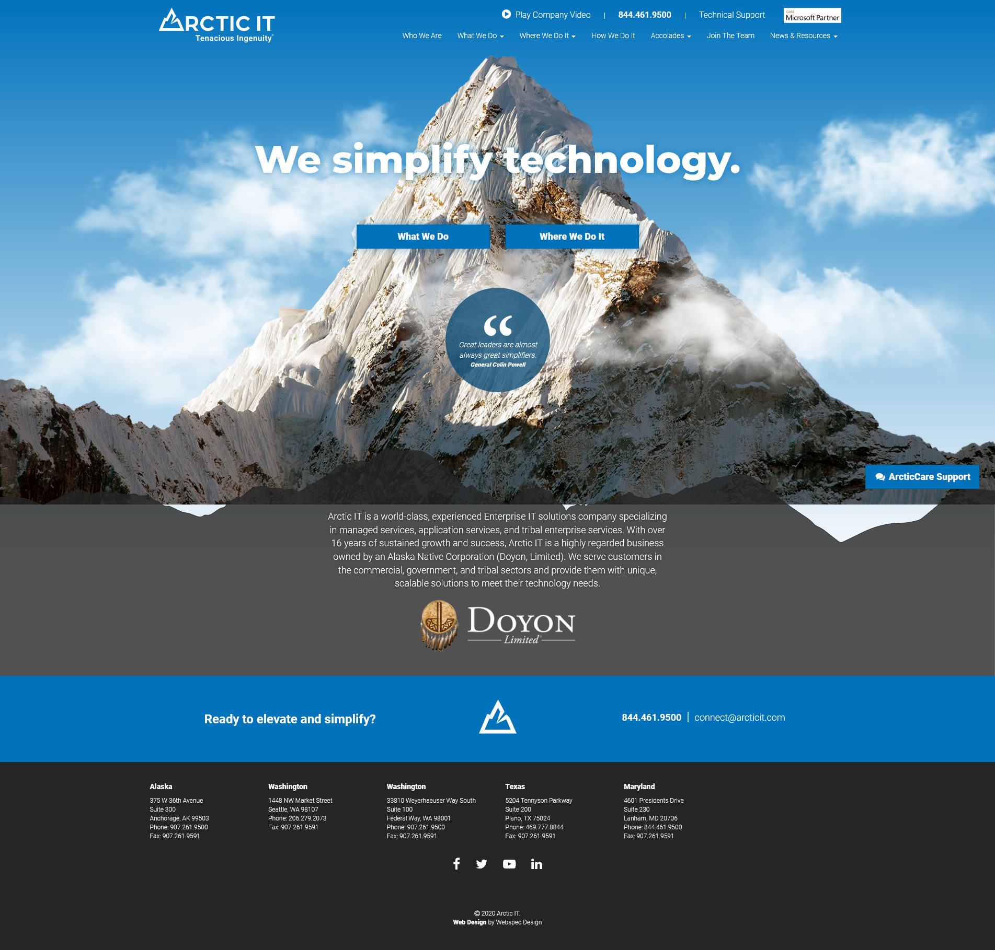

<https://arcticit.com/>

**Layout:** The layout on this particular page has many different shapes which lead the eye downward but still manages to be symmetrical.

**Grid:** This site does appear to use a type of grid and from what I can tell uses two columns. The elements are aligned side by side or right in the middle and changes by using animations.

**Unity:** I would say this site does have a sense of unity. It keeps the colors to blues, whites, and grays. And sticks with the same font all the way through.

**Focal Point:** Your eyes are drawn to the peak of the mountain and then center on the animated elements in the middle. Curiosity then takes control and you scroll further down to a paragraph on top of a shadowed mountain range. The site almost seems designed to draw your eyes downward.

**Contrast:** The blue sky Really makes the mountain’s white and grays pop! And the blue buttons stand out over the white mountain.

**Isolation:** The ArcticCare support call to action button is in a fixed position in the bottom right of the screen. It follows you as you scroll down.

**Visual Hierarchy:** The elements are together in the middle of the page and work with the background image to draw the eyes down. That changes once you reach the footer. Almost like a finish line.

**Continuation:** The elements are placed in a triangle like fashion which leads the eye down to the base where the footer is.